Dayton Flores & Mark Sherman

ECEN 5803-401

7/3/2022

Project 1 – Module 4

* For Doxygen documentation, see ***..\Code4\Doxygen***

1. The count shown in timer0 when letting it run for ~30 seconds is 0x0075E703 (7726851).

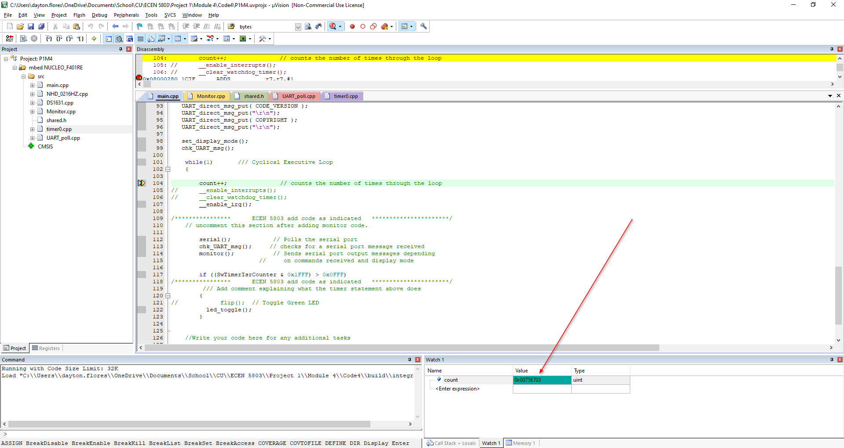

1. The code spends in the main loop versus in the ISRs.
2. See below for screenshots. Yes I am able to display all registers r0-r15. Something I did not expect is that upon doing a system reset, the buffer is not displaying my input characters properly (in the screenshot it is showing 29 when I enter V + carriage return)

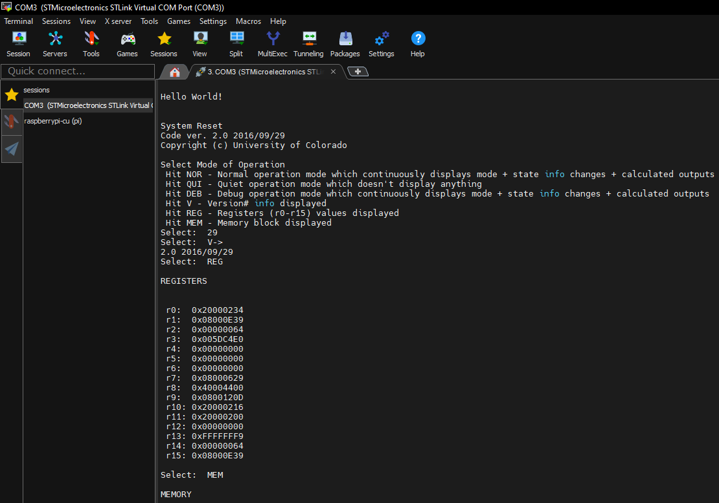

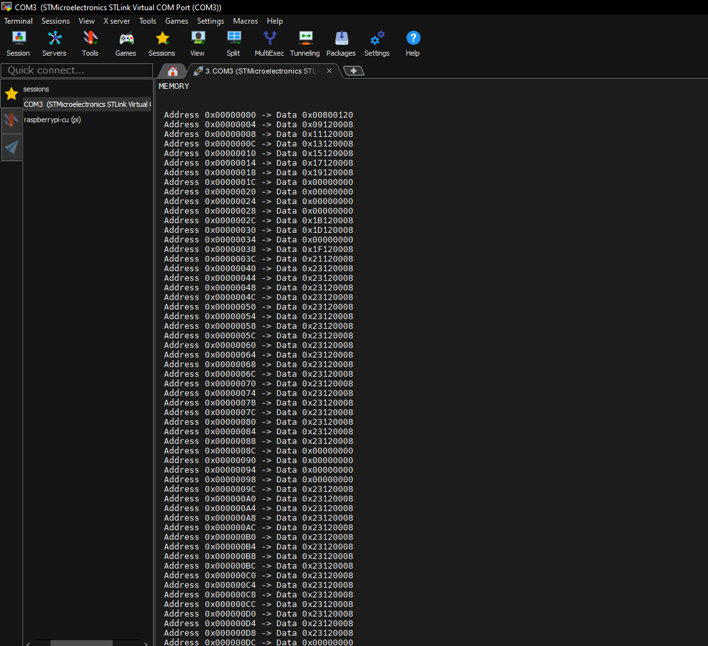

1. The new commands I added to the debug menu are to display Registers r0-r15 + Memory Block 0x00000000-0x00000100. For screenshots see #3 above.
2. The GPIO pin driven high at the beginning of the ISR and then low at the end.
3. The % of CPU cycles used for the main background process is .
4. DMIPS = Dhrystones Per Second / 1757

= 341887 / 1757

= 194.6 DMIPS

